Writing and Revision Guide for BIOL49X0R Courses

The goal of writing is to share information and ideas with others. Writing style, or the techniques writers use to convey their message, vary with disciplinary context, purpose for writing, and audience. Scientists use a common scientific writing style helps scientists engage with each other through their published research by promoting an efficient, streamlined mode of communication. Learning the conventions of scientific writing is incredibly beneficial for scientists-in-training. At the same time, these conventions should be viewed as guidelines for effective communication in the sciences rather than rules that must be followed.

Introduction
- Clarify all jargon in the Introduction.
- Any terms or concepts specific to your field of study is called “jargon.” While familiar to you, as an expert, they’re not general knowledge – even to other scientists! Be sure to define all key terms and key concepts in the Introduction so the reader understands your study.
- Define acronyms. At first mention, write the full name with abbreviation in parenthesis so readers know what you are referring to. Moving forward, use just the abbreviation.
  - Example: “To identify pigment type and quantity in firefly eyes, we used high-performance liquid chromatography with mass spectrometry (HPLC-MS).”
  - Example: “The enzyme tryptophan 2,3-dioxygenase (TDO) catalyzes the first step of the ommochrome pigment biosynthesis pathway (Figon & Casas, 2019).”
- For all species names, write the full, italicized Latin name once: Photinus pyralis and then use the abbreviation P. pyralis (note the genus is capitalized whereas the species is lowercase).
- Explain why you are doing the study.
- You may hear the phrase “gap in knowledge,” which just means: Why are you doing this study? Did prior work uncover an interesting trend you are now investigating further? What is the specific problem the research will address?
- To clarify the purpose of your study for the reader, use statements like “It remains unclear/unknown how/why…”
- Is your hypothesis or research question explicitly stated at the end of the Introduction?
- Use terminology like “We hypothesize” or “We will address the question…” to make clear what drives your work. By placing it at the end of your Introduction (narrowest part of the inverted pyramid), you transition readers into the Methods and Results sections, which are focused on your study.
- Example: “We hypothesize that fireflies use pink coloration to deter predators.”

Methods
- Explain your reasoning.
- In the Methods, your goal is to explain exactly what you did. In order for readers to determine if your results are robust and reliable, they need to read explicit details – not just about the experimental design but the why behind your choices for methodology: What is the purpose for each step of your approach, and why was it important to design your study this way?
- Avoid providing a list of steps. Instead, use “To do X, we did Y” format (initially described by Dr. Andrea Sweigart of the Genetics Department) to clearly state the purpose of each step.
  - This technique is generally used at the start of a new subsection to present the objective for each step of your approach. In order to understand and evaluate the methodology, readers must be able to follow your reasoning.
  - “To confirm our field identification of firefly species, we sequenced the COI mitochondrial gene, which has been established for taxonomic barcoding (Pentinsaari et al., 2016).”

Results
- Check figure and table formatting (see examples below).
- Table headers are placed above the table.
- Figure legends are placed below the figure.
- Figure and table legends should provide enough information that readers could interpret them with no additional context. All colors, symbols, abbreviations, etc. should be explained.

Table 1. Firefly collections at Lake Herrick

Species | Date | Time | Habitat | Number Collected
Photinus pyralis | 6/12/20 | 20:05 | Mixed woods and meadow | 4
Photinus australis | 6/12/20 | 19:48 | Edge of woods | 1
Photuris frontalis | 7/1/20 | 22:30 | Meadow | 2
Pyractomena borealis | 4/28/20 | 21:40 | Treetops | 3

Figure 1. Firefly signaling activity over a single evening (6/2/20, 28°C, 40% humidity). Observations of flashes recorded in 15-minute intervals from 17:00 to 22:00 from an open field. Color corresponds to species.

- Describe patterns in detail.
- Explain the research findings to your readers by going into depth on all trends observed, even if you didn’t uncover any clear trends.
  - Example: “We observed two species of twilight-active firefly, P. pyralis and P. australis (Figure 1). Both species became active shortly after 19:00 and steadily increased in abundance. P. australis reached their peak of activity at 20:15 with 28 individuals observed. P. pyralis rose more rapidly and peaked with 60 individuals at 20:30, indicating this species is more abundant than P. australis at this date and location.”
- Provide an objective report of your findings.
  - The Results are a summary of the findings before providing your interpretation of them in the Discussion.
  - Direct your reader to focus on certain patterns in your results. What should the readers pay attention to? In the example above, the author indicates to readers that there was an increase in firefly abundance.
- Rather than stating you found statistical significance, focus on the relationship you compared. For example, “There was a statistically significant difference between the groups.” could be revised to “The firefly abundance between rural and urban areas was significantly different.”
- Include references to all figures and tables in the text.
- References are not included in the Results.

Discussion
- Interpret your data by integrating evidence from your study with references.
  - To understand the biological meaning of your data, you must interpret your results and tie them into the “bigger picture.” How does your data align (or not!) with what other studies have found?
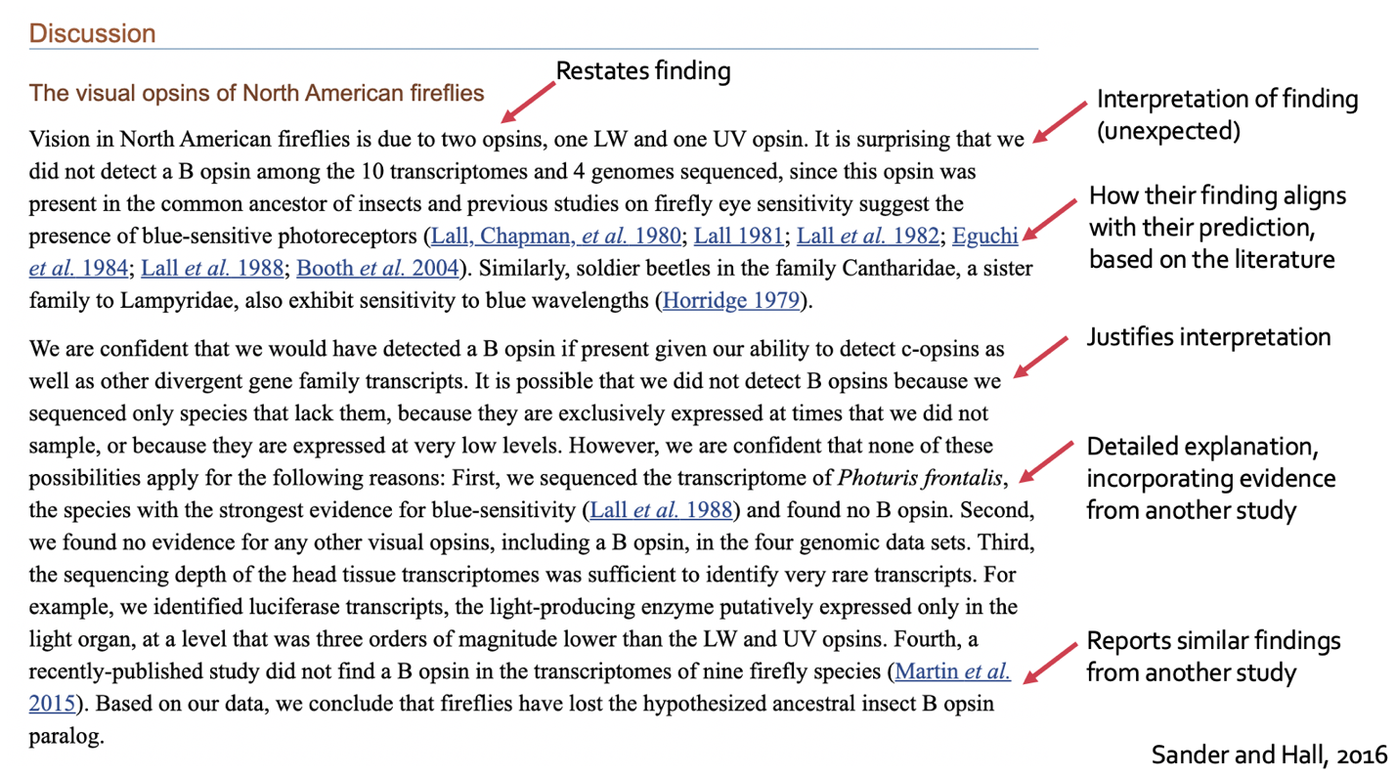
  - Example:

Reference: Sander, S. E., & Hall, D. W. (2015). Variation in opsin genes correlates with signalling ecology in North American fireflies. Molecular ecology, 24(18), 4679-4696.

- Address the limitations of your study.
- Identify aspects of your study design could hinder your ability to make conclusions.
  - For example, focusing on a subset of populations across a species range may be ideal for a pilot study but could not be used to evaluate that species as a whole. Be realistic about the scope of your study and offer recommendations to address the limitation (i.e., additional sampling).
- Time constraints, human error, learning how to use equipment don’t qualify as limitations, as they are inherent to the scientific process.
- Suggest future directions for your research.
  - What are the next steps of this research? Did your study raise any new questions? If your data is inconclusive, what would you want to try next?
    - For example, if you compared the number of active fireflies on one day, the next step could be surveying abundance throughout the season. It is possible that fireflies experience a peak and subsequent decline, so tracking numbers over time provides insight into the consistency of that pattern.
- Explain the broader implications.
  - Consider how your study moves us forward (even a tiny step is progress, and negative results are informative!) What was the benefit of this research?
    - Example: “Understanding when and where fireflies are active could help us identify effective conservation strategies.”

General
- Revisit the organization of in your writing.
  - Consider the structure, or how your ideas flow. Could reordering points or strengthening connections between ideas present your ideas more effectively to someone else?
- Use transitions between points to show how ideas connect. Use words or phrases such as “In conclusion, in contrast, in addition, similarly” to increase the flow of your writing and help readers follow your logic.
  - For example: “Adult fireflies emit flashes or glows of bioluminescent light, which they use for communication. In contrast, larval use bioluminescence to deter predators.”
- Use topic sentences to frame your points and summarize the main point of the paragraph, similar to “To do X, we did Y” format. For example: “There are many factors contributing to the decline in firefly abundance.” This sentence establishes the topic: reasons underlying firefly decline, priming readers for the information to come.
- Rather than use direct quotes, paraphrase their points and cite the author.
- ﻿Excerpt: “Across widely-distributed P. pyralis populations, we found no evidence for selection on the amino acid sequence of UV and LW opsins, the two light-detecting proteins in firefly eyes.” (From ﻿Lower & Hall 2018)
- Paraphrase: “No selection on UV or LW opsins was observed in P. pyralis fireflies (Lower & Hall, 2018).”
- Be consistent in the citation format you use (ex. APA, MLA).

Tips for Revising
- Read your writing out loud. What words or phrases sound clunky? Do any sentences have a comma that would sound better as a period?
- Edit: Did you italicize and spell all scientific names correctly? Check capitalization, punctuation, etc.
- Revisit your sentence structure.
  - Are there any places where you used the passive instead of active voice? Exception: The Methods section may be written in the passive voice.
    - Passive: “Fireflies were caught by Zena at twilight.”
    - Active: “Zena caught fireflies at twilight.”
    - Notice how the active voice is shorter, more concise, and direct by focusing on the action; this style of writing is easier for readers to understand.
  - Where could you use be more specific?
    - Not specific: “We measured the firefly.”
    - Specific: “We measured firefly light organs lengthwise using a microscope.” Specify how you measured and along what plane. Measuring lengthwise would yield different results than horizontally. Measuring under a microscope is more precise than by eye.
    - Not specific: “We aligned the transcripts.”
    - Specific: “We used RSEM (version v1.3.3) to align transcripts to the Photinus pyralis reference genome.” Report key details about your approach to data analysis so it could be replicated. Each software uses a different method, so it’s important to include the program and version.
    - Not specific: “We began data collection in the evening.”
    - Specific: “We began data collection at nautical twilight.” Terms like ‘evening’ are vague. Here, it’s unclear if data collection began at 7 or 9 PM. Nautical twilight has a specific meaning.
    - Specificity is key to rigor and reproducibility. Provide details so someone reading your methods could replicate your study and evaluate the rigor of your results.
- Revisit the biological content.
  - If you struggled with the writing process (for example, difficulty breaking down jargon, providing rationale, or explaining your findings) try revisiting the concepts underlying your research focus. Read research and review articles to clarify these topics. Additionally, ask your mentors questions about the biological concepts and study design.
- Read papers.
  - What words or phrases are used to frame points? How are the sentences structured? Model the conventions of this scientific writing style.

Writing Resources
- Schedule a conference with us! Contact Margot.Popecki@uga.edu to discuss your draft at any stage of the writing process.
- Attend our workshops on writing the Introduction, Methods & Results, and Discussion sections of a scientific research article. You can also watch our videos.
- Refer to the paper guidelines before and during the writing process.
- Make an appointment with the Science Library, UGA Writing Center, or Division of Academic Enhancement (DAE) to get feedback on your writing. The DAE also supports students in writing English as a second language.
- Please reach out at any time to raise any questions, concerns, or get assistance with your research paper. We want you to be successful!

Thank you to Dr. Holly Gallagher, Dr. Kristen Miller, and Dr. Lindsey Harding for their input on this revision guide.

References
Faust, L. F. (2017). Fireflies, glow-worms, and lightning bugs: identification and natural history of the fireflies of the eastern and central United States and Canada. University of Georgia Press.

Figon, F., & Casas, J. (2019). Ommochromes in invertebrates: biochemistry and cell biology. Biological Reviews, 94(1), 156-183.

Panter, M. (n.d.) Effective Transitions in Research Manuscripts. American Journal Experts. https://www.aje.com/arc/editing-tip-effective-transitions/
Pentinsaari, M., Salmela, H., Mutanen, M., & Roslin, T. (2016). Molecular evolution of a widely-adopted taxonomic marker (COI) across the animal tree of life. Scientific reports, 6(1), 1-12.

Purdue University. (n.d.) Topic Sentences. Purdue Online Writing Lab. https://owl.purdue.edu/engagement/ged_preparation/part_1_lessons_1_4/index.html

Sander, S. E., & Hall, D. W. (2015). Variation in opsin genes correlates with signalling ecology in North American fireflies. Molecular ecology, 24(18), 4679-4696.

